DIS- Moche- Tumi Ring-Copper-1200-1400 **B.C.E.**

1200-1400 A.D. Pre-Columbian Bronze Tumi Ring. The Tumi is a sacrificial ceremonial axe distinctly characterized by a semi-circular blade, usually made of either bronze or copper made of one piece and used by some Inca and pre-Inca cultures in the Peruvian Coastal Region. In Andean mythology, the Moche, Chimu and Incas were descendants of the Sun, which had to be worshiped annually with an extravagant celebration. During this important religious ceremony, the High Priest would sacrifice a completely black or white llama. Using a tumi, he would open the animal's chest and with his hands pull out its throbbing heart, lungs and viscera, so that observing those elements he could foretell the future. Later, the animal and its parts were completely incinerated.

Other Andean cultures have used the tumi for the neurological procedure of skull trepanation. Many of these operations were carefully performed, suggesting that the surgery was done for the relief of some body disturbance other than that associated with injury, perhaps an organic or mental condition.

In Peru, to hang a tumi on a wall means good luck.

This ring is a symbolic form of a real tumi which is actually a large blade (8-12 in. across). Perhaps this is meant to bring luck to its wearer. It measures approx. 1.5 in. tall and, though adjustable, the ring size is around a 10.

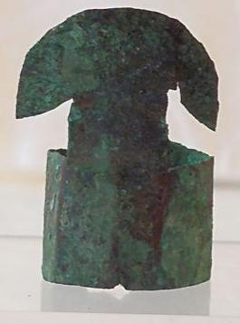 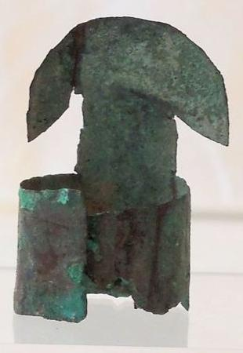 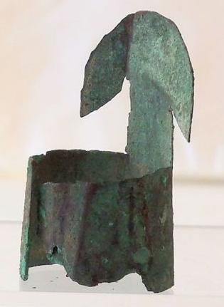

### Delivery package 1 of 1

Estimated delivery Wednesday, Dec 23, 2015 - Monday, Dec 28, 2015

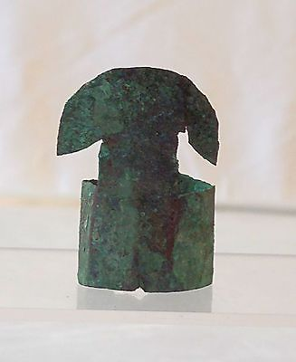

#### [Guaranteed 100 % Authentic Pre-Columbian Peru Bronze Tumi Ring](http://www.ebay.com/itm/121840433680)

|  |  |
| --- | --- |
| Item price | $65.00 |
| Quantity | 1 |
| Item number | 121840433680 |
| Shipping service | USPS Priority Mail |

